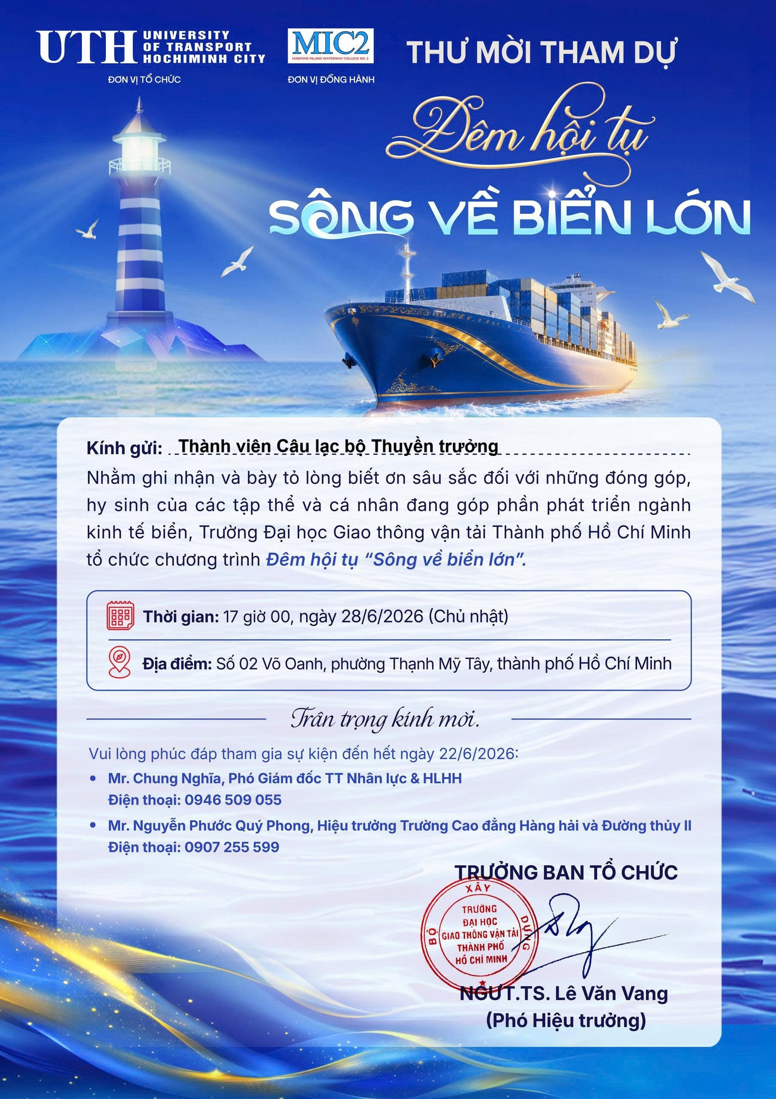
https://forms.gle/duNoz8uxJheHofaLA

